**Functional coverage Examples practice in eda**

**Explicit bins**

module tb();

logic [3:0] x;

logic [1:0] y;

covergroup cg;

option.per_instance = 1;

coverpoint x {

bins a[] = { [3:10], 13,14,15 }; //vector bins

bins a1 = {11,12}; // scalar bins

}

Y : coverpoint y; //implicit bins

endgroup :cg

initial

begin

cg c = new();

repeat(50)

begin

{x,y} = $urandom();

c.sample();

end

end

initial

begin

#500;

$stop();

end

endmodule

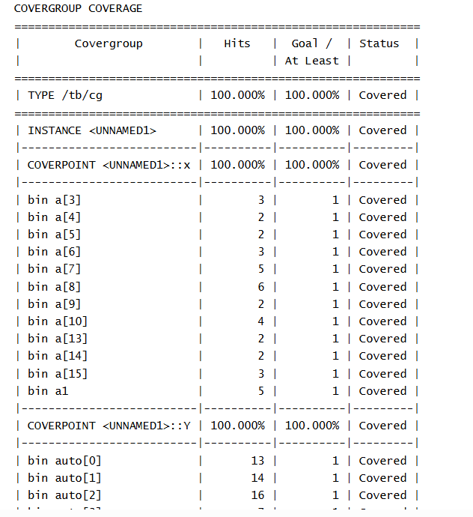

**Implicit bins**

module tb();

logic [3:0] x;

logic [1:0] y;

covergroup cg;

option.per_instance = 1;

X : coverpoint x;

Y : coverpoint y;

endgroup :cg

initial

begin

cg c = new();

repeat(50)

begin

{x,y} = $urandom();

c.sample();

end

end

initial

begin

#500;

$stop();

end

endmodule

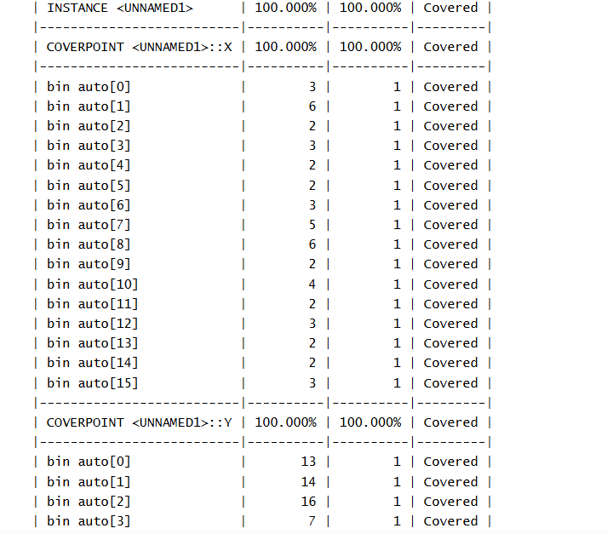

**Cross bins**

module tb();

bit [3:0] x;

bit [1:0] y;

bit rst;

covergroup cg;

option.per_instance = 1;

X : coverpoint x; //2^M bins -> 2^4 16 bins

Y : coverpoint y; // 2^2 4 bins

coverpoint rst {

bins R[] = {[0:1]}; // 2 bins

}

XxY : cross X,Y;

Xxrst : cross X,rst;

Yxrst : cross Y,rst;

XxYxrst : cross X,Y,rst;

endgroup :cg

initial

begin

cg c = new();

repeat(50)

begin

{x,y} = $urandom();

c.sample();

end

end

initial

begin

#500;

$stop();

end

endmodule

